Mission Peak Optics Inc.
Portable Thin Film Measurement System MP100-ST
Easy to use + Low Cost + Compact Size + Flexibility = High Performance
The MP100-ST system comes standard with a portable spectrometer, optical probe mounted on a manual X, Y stage, a secondary transmission light source, and a laptop computer pre-loaded with MPO software. This software contains hundreds of pre-loaded film recipes with the ability to create and edit new ones. The MP100-ST can measure Oxide, Nitride, Photoresist, Polysislicon, CIE chromaticity, cell gap, color filter thickness, as well as polyemide/ITO. The portability of this compact system allows you to put the probe into the Measurement site.
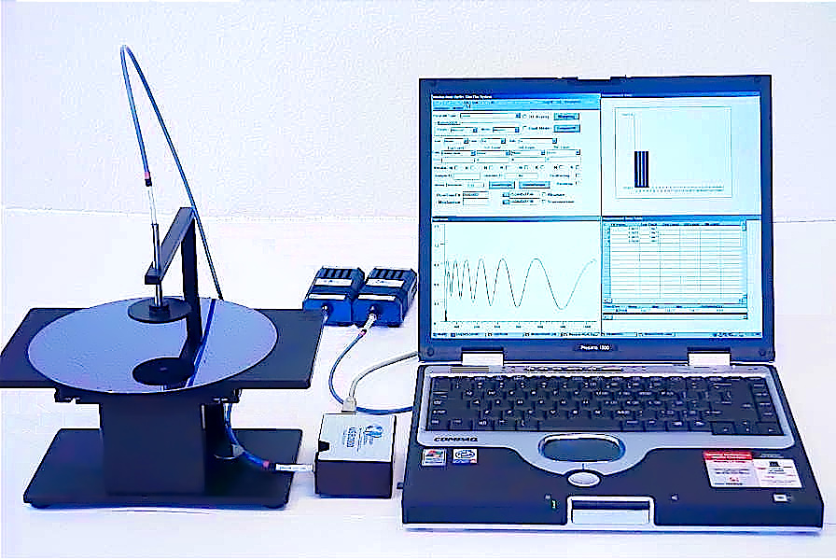

XY stage
Light Source
Spectrometer
USB
Bifurcated Optical Probe

The MP100-ST probe can be dismounted from the stage and hand held to access hard to reach areas. Applications include reflectivity of a surface, textile color of a material, liquid concentration, and material inspection all with real-time spectral analysis. The probe can be configured for a working distance up to 6 inches with a varying measurement spot size.

The MP100-ST positioning mechanism is set by a X, Y stage. Allowing you to quickly locate the sample position. When the selected sampling position has been reached, measurements can be taken precisely and accurately without the X, Y stage drifting.

There is an add-on option for a programmable X, Y stage from 4 to 12 inches of travel.

With the Transmission option, the system can perform a Dual Mode measurement to obtain the precise N, K data.
MP100-ST Portable Thin Film Measurement System
Second Light Source with Transmission Mode
Specifications (MP100-ST):

Scanning range: 380 nm to 950 nm, Standard
Optional range: 200 nm to 2500 nm
Spectrum resolution: 2 nm in Visible 4 nm in NIR
Precision: 0.2 nm
Measuring speed: 2 seconds (Standard Wavelength Range)

Measurement specification:

 |  | 1st Layer |  | 2nd Layer |  | 3rd Layer  1σ  0 - 10,000 Å  5 Å |  | 4 th Layer
Film Type | Objective | Range | 1σ | Range | 1σ | Range | 1σ | Range | 1σ
P1/P2/ITO/SiO2/Glass | Probe | 100 - 3,000 Å | 3Å | 100-3000 Å | 3Å | 100-1500 Å | 3Å | 100-1500 Å | 3Å
Oxide/Si | Probe | 200 ,- 30,000 Å | 2Å
 |  | 30,000 ,- 050,000 Å | 5Å
 |  | 50,000 - 100,000 Å | 20Å
Nitride/Si | Probe | 150 ,- 020,000 Å | 2Å
Photoresist/Si | Probe | 500 ,- 020,000 Å | 5Å
Nitride/Oxide/Si | Probe | 150 ,- 020,000 Å | 5Å | 150-20,000Å | 5Å
Poly/Oxide/Si | Probe | 100 ,- 5,000 Å | 5Å | 0-10,000Å | 5Å
Oxide/Poly/Oxide/Si | Probe | 100 ,- 010,000 Å | 5Å | 0-10,000Å | 5Å | 100-10,000 Å | 5Å
Oxide/Al | Probe | 2,000 ,- 020,000 Å | 5Å
Photoresist/Cr | Probe | 500 ,- 020,000 Å | 5Å
Oxide/NiFe | Probe | 2,000 ,- 020,000 Å | 5Å
Photoresist/Glass | Probe | 500 ,- 20,000 Å | 5Å
ITO/Oxide/Glass | Probe | 100 - 3,000 Å | 2Å | 100-2,000Å | 2Å
Very Thick film | Probe | 1000 - 500,000 Å | 100Å
Customized film types are available for your applications.

Measuring spot size: 3 to 5 mm diameter

Mission Peak Optics Inc.
46941 Rancho Higuera Road, Fremont, CA 94539 USA
Tel: (510) 438-0384 Fax: (510) 438-9795
Website: www.missionpeakoptics.com Email: sales@missionpeakoptics.com

